# What is BashaLagbe.com?

**BasaLagbe.com** is a web-based platform. The platform will help users to rent houses, flats, offices online. Users can also post rent ads on this platform. There are 2 types of user in our platform.

By clicking available house renter can see a full description of the house including rent fee and house details. That’s mean our platform will give perfect overview about the house.

Landlord can post rent ads on this platform by verifying his account. Here he can easily give rent by posting attractive and informative add.

**Features of our Website:**

1. **Login/ Register Page**

In registration section, one must enter his name, mail, phone number, password and user type for completing his registration and then one can log into our website.

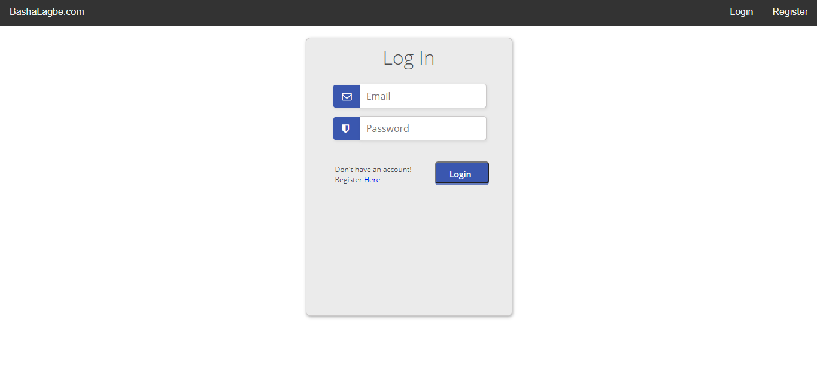

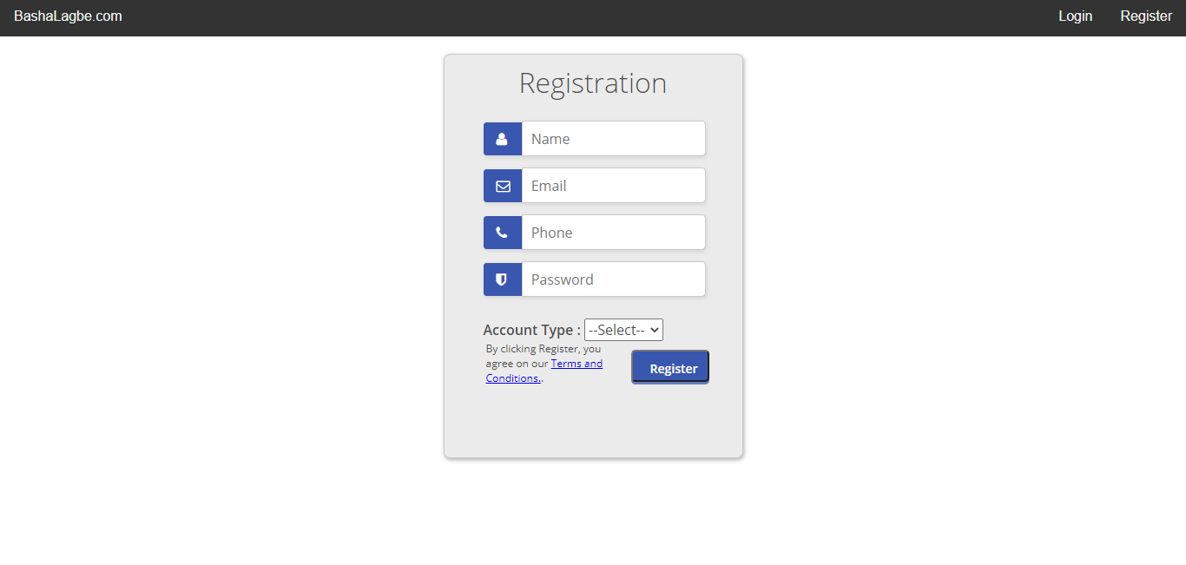

1. **Home Page**

In our home page there are several sections. First there is a filter section. Here one search **AD** by selecting specific location.

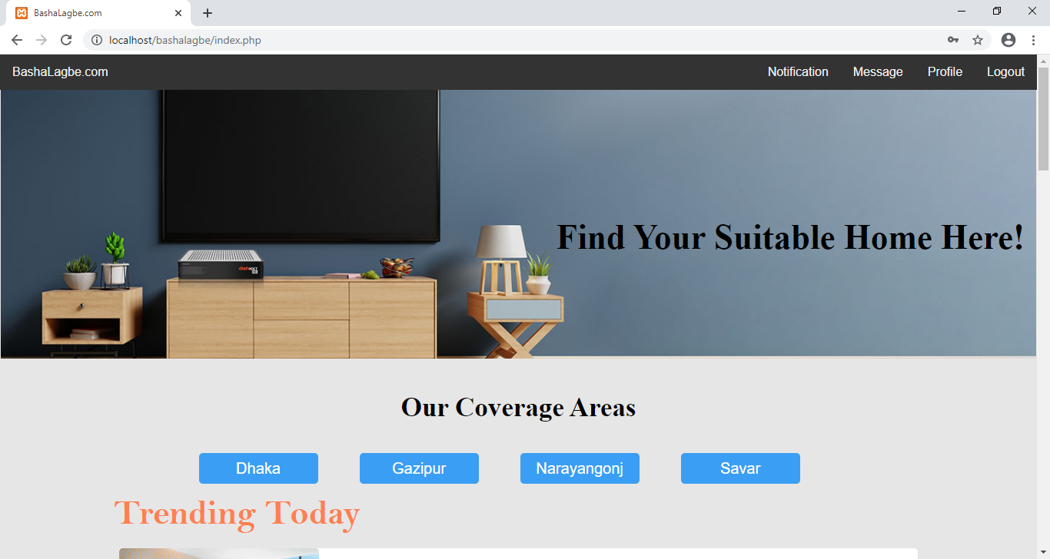

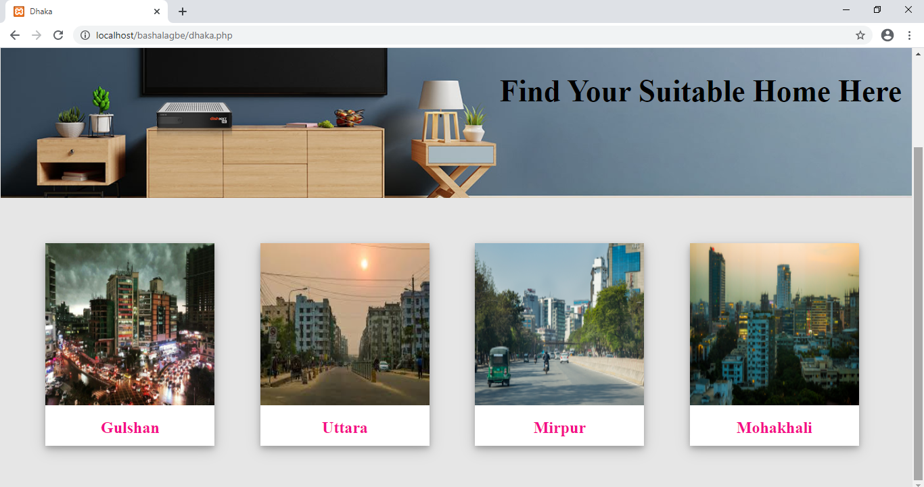

After that there is a “Trending” section where all the tending Ads will appear and in “All in One” section all the Ads will appear.

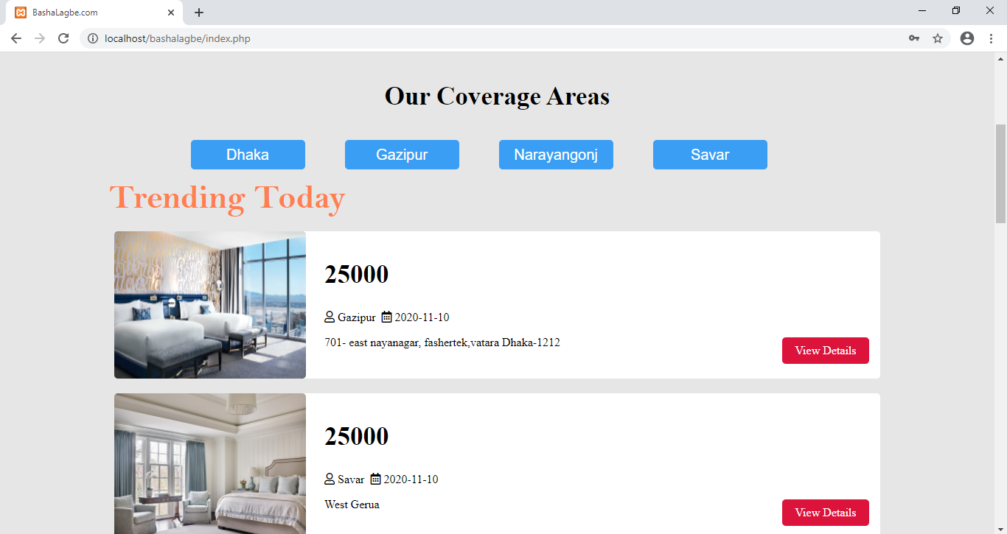

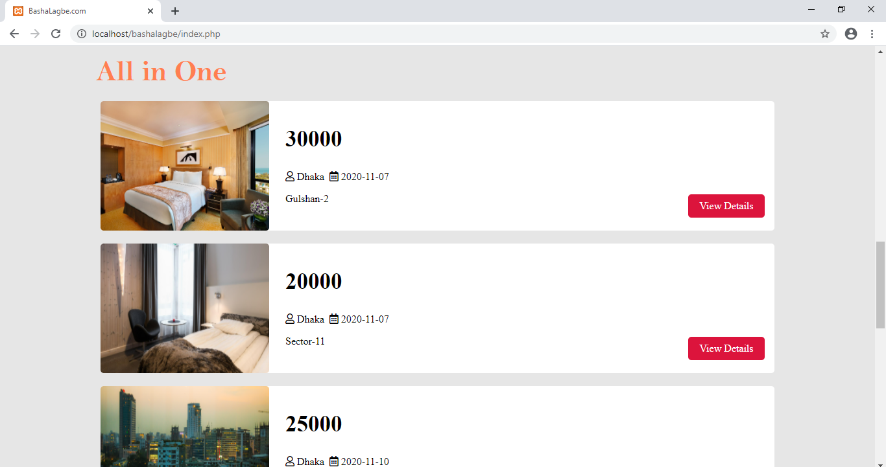

1. **User Profile Page – (Landlord, Renter)**

In our website we have 2 types of user 1. Landlord and 2. Renter. In user profile dashboard section we have tried to give an overview about payment and other history.

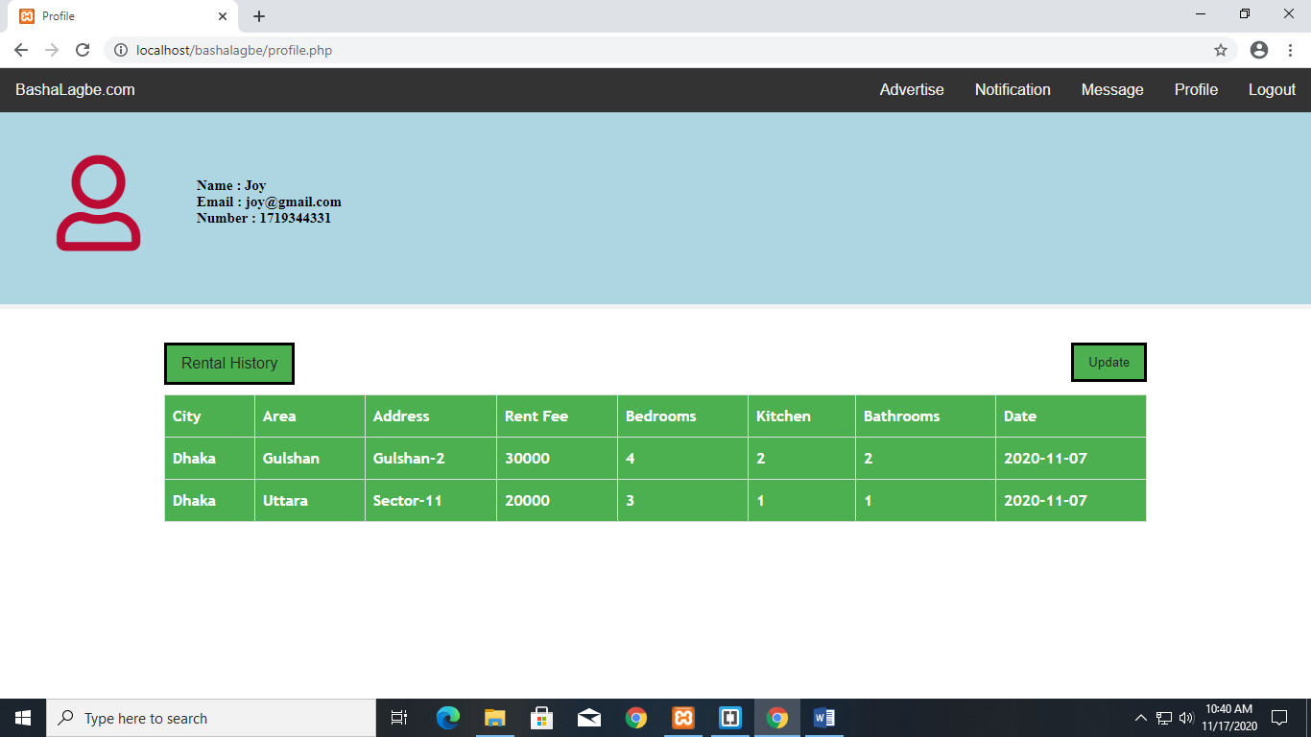

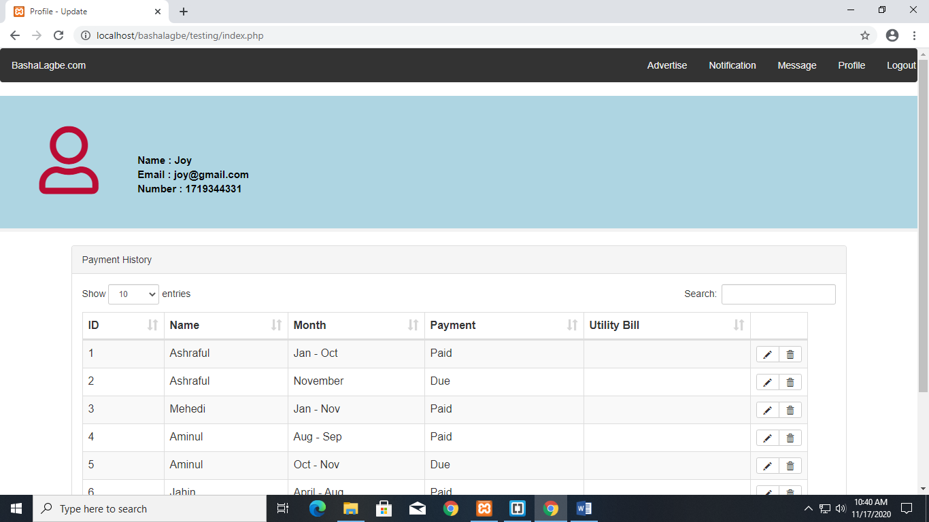

1. **Advertise Page**

Here in advertise section landlord can post an Ad by giving full description of his home he wants to rent.

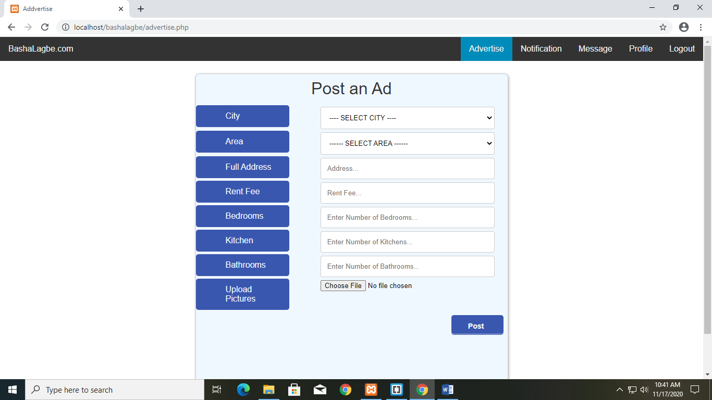

1. **Notification**

Here any kinds of important will appear. Like rent request, rent confirmation will be shown.

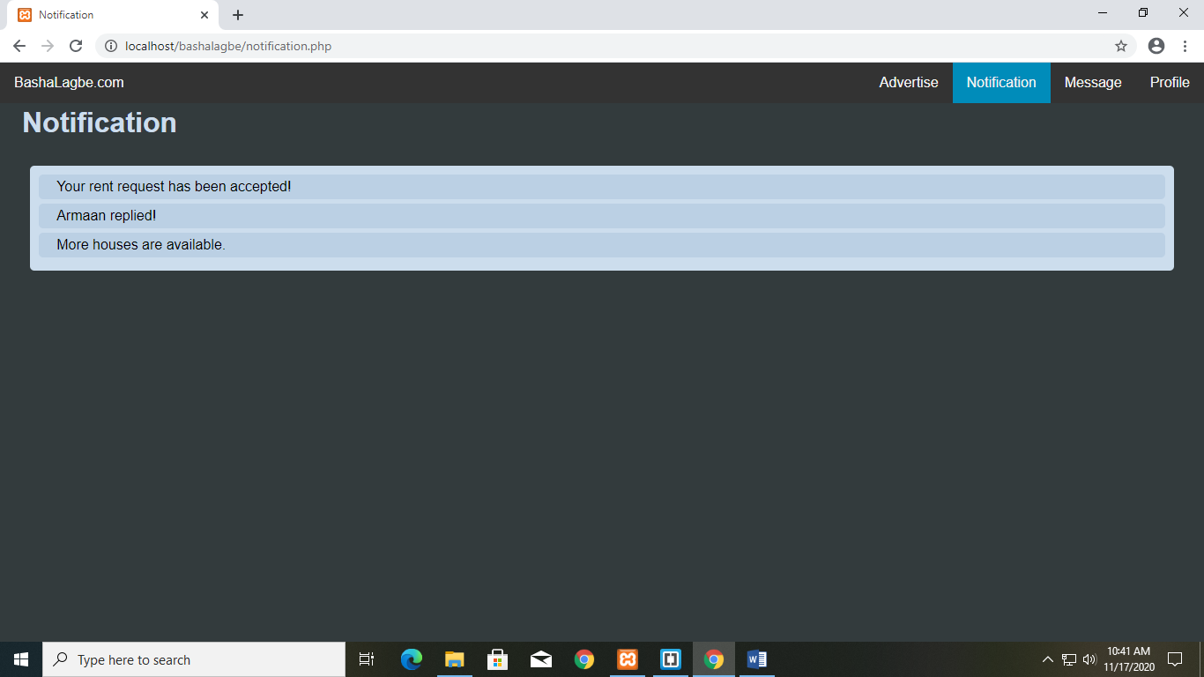

1. **Message**

Here we are trying to build a communication platform between the users.

